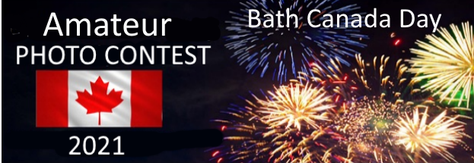
2021 BATH CANADA DAY 2021
AMATEUR PHOTO CONTEST RULES

PHOTOGRAPH SUBJECT, FORMAT AND SIZE.
- Photographs should follow the theme.
Celebrating Canada Day: History, Family, Friends
- Photograph to be taken anytime on July 1st 2021 within Loyalist Township
- Photograph must be submitted in digital format either black and white or colour.
- Photograph can be manipulated but must start from an eligible original.
- File to be .jpg format and at least 1MB or larger in size.
- No names or descriptions to be attached to the photograph.
- All entries remain the property of the photographer but Loyalist Township is granted the right to freely use the image with appropriate credit.

CONTEST CATEGORIES
- There are three categories of entrants.
  - GROUP 1. Under 12 years of age.
  - GROUP 2. 12 to 17 years of age.
  - GROUP 3. 18 years old and older.
- Entrants 17 and younger to submit parent/guardian authorization to enter.

ELIGIBILITY TO ENTER CONTEST AND SUBMISSION DETAILS
- Entrants to be amateur photographers only.
- Photograph must have been taken by entrant.
- Photograph to be taken anytime on July 1st 2021 within Loyalist Township.
- Entries submitted by email to bathcanadadayphotocontest@gmail.com
- One photograph per person.
- Submissions to be received by end of day 5th July/21
- Entrants must residents of Loyalist Township.
- Entry must include name, age category, date of birth (if under 18), address & telephone number.
- Entrants 17 and younger must submit parent/guardian authorization to enter.

JUDGING
- An independent trio of anonymous judges from other regional photo clubs.
- Judging will be based on quality, composition, subject, originality,
WINNERS AND PRIZES
- Judges will select 1st, 2nd & 3rd winners in each of the age categories.
- Finalists to sign Loyalist Township standard release form before being confirmed.
- Submissions that do not meet the requirements posted on the BCD website will be disqualified.
- All winners will be notified by email.
- Winning photos will be posted on social media.
- Prizes will be in $225 worth of gift cards (3x$50, 3x$25 & 3x$10) from the local Bath merchants of winner’s choice.
- All decisions are final.

REV 9. 10 June 2021

